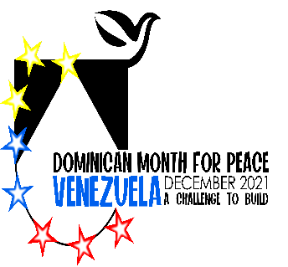
The Catholic Church and the Dominican Order in Venezuela

The Church’s roots in Venezuela began with the missionary activities of the religious orders sent from Spain and Hispaniola.
In 1516 Cardinal Francisco Cisneros of Spain sent two royal decrees to the Hieronymite friars who governed Santo Domingo and its dependencies, requesting that they assist the Dominicans and Franciscans doing missionary work on the Gulf of Santa Fe, Chichirivichi and Cumaná. These documents referred to two missionaries killed by natives in reprisal for mistreatment by intruding conquerors. The missions established by the Church gradually evolved into towns, villages of converted natives and parishes with their own curates, and provided a means of freeing Venezuelan natives from the sadly famous encomienda, a kind of fief of the new Spanish masters
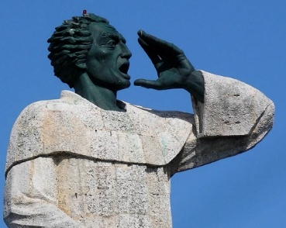
Around 1515, Pedro De Córdoba, the Dominican prior of the convent that challenged (through Montesino’s preaching) the Conquistadors’ treatment of the Indians, requested a land grant on the northern coast of South America which barred Spanish activity. De Córdoba hoped that the land would serve as a haven for Indians from the nearby slave raiding and for missionary work. When Las Casas showed the letter the Council of the Indies, the Bishop of Burgos laughed at the idea of granting land that would return no profit for the Crown. The establishment of the mission ended in a massive massacre by the Spaniards in which the missionaries were also victims including Juan Garces, the repentant conquistador turned Dominican lay brother.
The Dominicans continued their mission in Apure and Barinas, where they founded 20 towns. Under the constitutions for the establishment of the Church organization in Venezuela, the first diocesan synod was held in Coro, on July 26, 1574, during the episcopate of Pedro de Agreda, a Dominican who governed the diocese from 1561 to 1579. Juan Manual Martínez de Manzanillo OP also served as Bishop of Coro 1583-1592. ^{Catholic Church Venezuela}
The bishops not only organized the hierarchy in Venezuela but also contributed generally to the development of the country.
- González de Acuña, founder of the Tridentine Seminary in Caracas in 1673 introduced safe drinking water to the city.
- Diego de Baños y Sotomayor called the synod of 1686.
- Juan José Escalona y Calatayud established the Royal Pontifical University in 1725.
- Pious Antonio Diez Madroñero was a zealous reformer.
Political Upheaval and Independence. The 19th century was characterized by political upheaval throughout much of South America. In 1806, the activities of Simon Bolívar and the Columbian Independence Movement eventually resulted in Venezuela's declaration of independence from Spain on July 5, 1811. By 1830, General José Antonio Páez was elected as its first president. While Páez provided stable leadership, such was not the case with future administrations, which saw a proliferation of political violence under a succession of dictators.
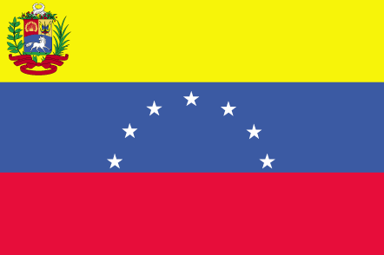
As a consequence of the succession of politically unstable dictatorships that followed independence, the missions declined during the mid-19th century. Under the Spanish rule, the government had the Papal privilege Patronato controlling major appointments of Church officials, the management of Church revenues, approval of correspondence, and other realities which would make the Church subservient to the government. The hierarchy was expected to swear allegiance to the new Constitution which did not acknowledge the Catholic Church as the official religion of Venezuela. The Church was traditionally allied with the Royalist sympathies of Spain, so much tension arose between the Church and the Government. Without any fresh ratification or negotiations with the Holy See with respect to this privilege, Venezuela incorporated the Patronato in its legislation (14 October, 1830). Ramón Ignacio Méndez, Archbishop of Caracas with several of his bishops were sent into exile for refusing to co-operate with the government.
The missions declined during the mid-19th century, as no good understanding could be reached, and political passions helped to make the rupture more and more irremediable, and the disastrous results became lamentable in the extreme. Some consequences included:
- Expelling with savage violence the last communities of religious women left in Venezuela,
- suppressing the seminaries,
- ruin of that budding revival of ecclesiastical education which already constituted a fair hope for the country's progress in civilization
- destroying churches, taking possession of buildings, pious institutions, and sacred property of every kind,
- abolishing the revenues of the Church and its institutions
- appointing subservient ecclesial officials Catholic Encyclopedia 1911
During the 20th century the Salesians, Daughters of Mary, Sisters of Charity of St. Anne, Franciscan Sisters of Venezuela, Capuchin Tertiaries, Dominican Sisters of Granada and Missionary Sisters of Mother Laura were active in the country. The Little Brothers of Jesus worked among the Makiritar of the upper Caura, a diocesan mission of the Archdiocese of Ciudad Bolívar. Lastly, in1903,the Dominican Fathers, also under government protection, took possession of the Church of the Sacred Heart of Jesus at Caracas. They are gaining more and more in the esteem of society at large and the appreciation of the metropolitan. Certain members of their community were engaged in teaching in the seminary of Caracas. It appears their presence was short lived but reestablished around 19---

This period was marked by the Juan Vicente Gómez (1908 - 1935) and the discovery of oil in the country. While the country became one of the world’s largest exporters. The largesse did not improved the lives of the poor and the country suffered from the ravages of racist policies. The country was ruled by a variety of dictatorial/military regimes until a democratically president in 1958.

Relations between the Roman Catholic Church and the Venezuelan state have been harmonious throughout most of the twentieth century. The Venezuelan church was not well endowed economically. It owned little property and received only limited private contributions. The government contributed a large part of the church's operating expenses through a special division of the Ministry of Justice. Government funds generally covered the salaries of the hierarchy, certain lesser functionaries attached to the more important episcopates, a limited number of priests, and the missionaries to the Indians. In addition, government contributions sometimes paid for religious materials, for construction and repair of religious buildings, and for other projects submitted by bishops and archbishops and approved by the ministry. 20th century church

Since the Second Vatican Council, the Roman Catholic Church in Venezuela has been weakened by a lack of diocesan and religious vocations. Many priests serving in Venezuela are foreign-born. In the past, the Catholic Church did not have the funds, the personnel, or the enthusiasm to stem effectively this new challenge to its hegemony, but it believed it faced a greater threat with the new government of Hugo Chavez.
Although President Chávez self-identified as a practicing Roman Catholic, his policies have concerned the Venezuelan Roman Catholic hierarchy, especially in the area of religious education. Besides its universities and colleges, the Roman Catholic Church also administers some 700 other schools throughout the country, mostly subsidized by the Venezuelan state. In 2007, Cardinal Jorge Urosa, the Archbishop of Caracas, called for peaceful demonstrations against any direct government involvement in overseeing the Church's administration of schools. The Church has also been critical of the government for wanting to remove religious education from public schools during normal school hours.

Resources
The Dominicans in America
^{Catholic Church in Venezuela}

