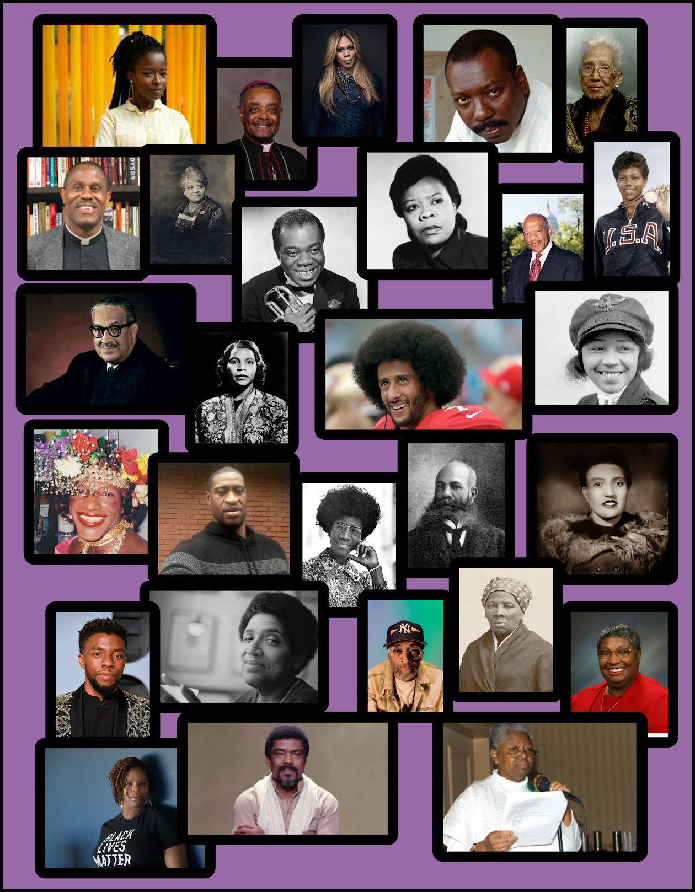

Black History Month 2021
Sunday | Monday | Tuesday | Wednesday | Thursday | Friday | Saturday
 | 1 | 2 | 3 | 4 | 5 | 6
 | Amanda Gorman | Wilton Daniel Gregory | Laverne Cox | Jacob Lawrence | Katherine Johnson | Bryan Massingale
7  Ida B. Wells | 8  Louis Armstrong | 9  Marie Van Brittan Brown | 10  John Lewis | 11  Wilma Rudolph | 12  Thurgood Marshall | 13  Marian Anderson
14 | 15 | 16 | 17 | 18 | 19 | 20
Colin Kaepernick | Bessie Coleman | Marsha P. Johnson | George Floyd | Shirley Chisholm | Alexander Miles | Henrietta Lacks
21  Chadwick Boseman | 22  Audre Lorde | 23  Spike Lee | 24  Harriet Tubman | 25  Alexa Canady | 26  Patrisse Cullors | 27  Alvin Ailey
28
Martin de Porres Grey

Created by Racial Justice Working Group under the Justice Committee, JPIC Sisters of St. Joseph Brentwood

Week 1
Feb 1 | Amanda Gorman  (1998- ) | Catholic/Poet/ Activist/ First National Youth Poet Laureate/ Youngest Poet to read at the Inauguration | “...And yet, the dawn is ours before we knew it.  Somehow we do it.  Somehow we’ve weathered and witnessed  a nation that isn’t broken,  but simply unfinished.” | Read the works of T en Most  Famous Black Poets and Their  Best Known Poems
Feb 2 | Wilton Daniel Gregory  (1947- ) | Catholic Priest/First African American Cardinal in the United States/ Archbishop of Washington, DC | “Like any other spiritual transformation or renewal, conversion must begin with an honest and a sincere admission that we need God's trans-formative power in our lives to achieve any real change, no matter the perspective from which we might begin.” | Learn about the connection  between the Catholic Church’s  Doctirne of Discovery and  Slavery
Feb 3 | Laverne Cox  (1972- ) | Actress/first openly transgender person to be nominated for a Primetime Emmy Award | “When people have points of reference that are humanizing, that demystifies difference.” | Learn about the work of N ew  Way’s Ministry and Outreach  to Transgender Persons
Feb 4 | Jacob Lawrence  (1917-2000) | Painter/best known works, The Migration Series which depicts the migration of African-Americans from the rural south to the urban north. | “...We don't have a physical slavery, but an economic slavery. If these people, who were so much worse off than the people today, could conquer their slavery, we can certainly do the same thing. I am  not a politician. I'm an artist, just trying to do my part to bring this thing about.” | Take a Virtual Tour of Jacob Lawrence: The American Struggle on display at the  Peabody Essex Museum
Feb 5 | Katherine Johnson  (1918-2020) | NASA  Mathematician/ provided calculations of orbital mechanics for first US space flights/Awarded Presidential Medal of Freedom | “Everything is physics and math.” | Watch or rewatch the movie,  Hidden Figures
Feb 6 | Bryan Massingale  (1957- ) | Catholic priest/author/ activist/ theologian | “For the beneficiaries of white privilege lament involves the difficult task of acknowledging their individual and communal complicity in past and present racial injustices” | Watch “ The Magis and Justice”
Feb 7 | Ida B. Wells  (1862-1931) | Journalist/ Anti-lynching  activist/Women’s Suffragist | “I am only a mouthpiece through which to tell the story of lynching and I have told it so often that I know it by heart. I do not have to embellish; it makes its own way.” | Read how lynching became a  federal crime in 2020.  View photos of real lynchings

Created by Racial Justice Working Group under the Justice Committee, JPIC Sisters of St. Joseph Brentwood

Week 2
February 8 | Louis Armstrong  (1901-1971) | Musician/Trumpeter/ Among most influential in Jazz/Nickname: Satchmo/NYC Native | “Seems to me, it ain’t the world that's so bad but what we're doin' to it. And all I'm saying is, see, what a wonderful world it would be if only we'd give it a chance. Love baby, love. That's the secret.” | Watch and Listen to Louis Armstrong in this BBC Special
February 9 | Marie Van Brittan Brown  (1922-1999) | Nurse/Inventor/invented closed circuit TV initially for home security/Jamaica, Queens native | “Since 1993 property crime has fallen in the US by 69% thanks to the pioneering work of one woman: Marie Van Brittan Brown”  UntoldEdu | Read story with the New York Times,” N ew York Times,  December 6, 1969 (“Audio-Viewer  Screens Calls)p.55
February 10 | John Lewis  (1940-2020) | Politician/Civil Rights Activist | “Get in good trouble, necessary trouble.” | Take a Virtual Tour of the National  Museum of African American  History which John Lewis initiated in 1988.
February 11 | Wilma Rudolph  (1940-1994) | Polio survivor/ gold medal Olympian/ coach/ activist | ‘I have spent a lifetime trying to share what it has meant to be a woman first in the world of sports so that other young women have a chance to reach their dreams.” | Write a letter to your representative to support equity in health care.
February 12 | Thurgood Marshall  (1908-1993) | Lawyer/activist/ argued Brown v Board of Education/ first Black Supreme Court Justice | “None of us got where we are solely by pulling ourselves up by our bootstraps… – a parent, a teacher, an Ivy League crony or a few nuns – bent down and helped us pick up our boots.” | Read MLK's “Letter from a  Birmingham Jail”.
February 13 | Marian Anderson  (1897-1993) | Opera contralto/ first Black person to perform a leading role at the Met/ diplomat/ activist | “A singer starts by having his instrument as a gift from God... When you have been given something in a moment of grace, it is sacrilegious to be greedy.” | Listen to/watch Marian sing from  the Lincoln Memorial.

February 14 | Colin Kaepernick  (1987- ) | Athlete/ activist/ philanthropist | “People sometimes forget that love is at the root of our resistance.” | Journal “Why kneeling is an act of love.”

Week 3
February 15 | Bessie Coleman  (1892-1926) | First Black/ Native American US female pilot/first Black international pilot/activist | “I refused to take no for an answer.” | Journal “What could be the questions she asked for which the answer was no?”
February 16 | Marsha P. Johnson  (1945-1992) | Gay liberation activist/ self-identified drag queen/prominent figure in Stone Wall Uprising | “I’ll always be known reaching out to young people who have no one to help them out, so I help them out with a place to stay or some food to eat or some change for their pocket.” | Pray for those marginalized by racism- say their names.
February 17 | George Floyd  (1973-2020) | Son/ father/ truck driver/ security guard | Last recorded words- “I can't breathe. I can‘t breathe…. Please. Please. Please.” | Read the book: Between the  World and Me- Ta-Nehisi Coates letter to his son.
February 18 | Shirley Chisholm  (1924-2005) | NY state politician/ educator/ author/ first Black candidate for major party nomination for President | ”If they don’t give you a seat at the table, bring a folding chair.” | Write supporting an action to address racism in housing, healthcare, or business.- How  to Contact Your Elected  Officials  .
February 19 | Alexander Miles  (1838-1918) | Laborer/ barber/ inventor of automatic elevator doors/ inducted into Inventors Hall of Fame 2007 | “I think it is time that the nation should awaken to the fact that the negro is a citizen and not a pest,” | Read “The legacy of George  Floyd: Here’s how business can  address inequality and  promote justice”
February 20 | Henrietta Lacks  (1920-1951) | Exploited for medical research/ “immortal cells” which have helped countless patients. | “Who is this Henrietta Lacks?!” | Watch or read  “The Mother of Modern  Medicine”

February 21 | Chadwick Boseman  (1976-2020) | Award winning actor/ playwright/ played Jackie Robinson, James Brown, Thurgood Marshall, Black Panther | “The struggles along the way are only meant to shape you for your purpose.” | Watch M arshall or 42 or pray for his young family.

Week 4
February 22 | Audre Lorde  (1934-1992) | NYC public school librarian/ feminist writer/ civil rights activist | “Life is short and we must do what has to be done in the now.” | Read Sister Outsiders or  A Burst of Light
February 23 | Spike Lee  (1957- ) | Actor/film director/ screenwriter/ professor | “And this city (NYC) is so vibrant; the energy is just phenomenal.” | Watch any one of his  movies, TV shows, e.g. Do  the Right Thing
February 24 | Harriet Tubman  (1822-1913) | Abolitionist/political activist/ part of the “Underground Railroad” | “I never ran my train off the track, and never lost a passenger.” | Watch H arriet, on YouTube, Amazon, Hulu
February 25 | Alexa Canady  (1950- ) | First African American woman neurosurgeon/ “retired” to be chief of pediatric neurosurgery/ Sacred Heart, Pensacola | “If you want to be something, you have to perceive that something is possible.” | Watch CNBC “Black  doctors push for  anti-bias training in  medicine” or read
February 26 | Patrice Cullors  (1983- ) | American artist/ activist/ co-founder of Black Lives Matter | “Invest in a culture of dignity and care for Black people.” | Explore Patrice’s website and pick an action.  Pray for racial justice.
February 27 | Alvin Ailey  (1931-1989) | Dancer, choreographer, director, founder of the American Dance Theatre, activist. | “Color is not important. What is important is the quality of our work.” | Watch R evelations on YouTube

February 28 | Martin de Porres  Grey  (1942?- ) | First Black woman in the Sisters of Mercy; foundress of Nat. Black Sisters Conference, 1968; left religious life in 1974. | “I never allowed myself to actually experience the pain of it.” | Check out the work of Shannen Dee Williams. “Black Nuns and ‘Subversive Habits’” Pray for religious life.

